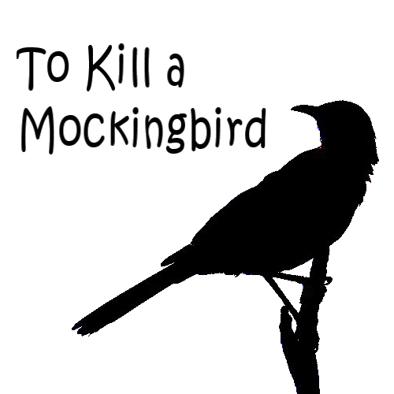

Name:__________________________________________________

Hour:_____________________

As you read To Kill a Mockingbird, answer the following questions. They will prepare you for class discussions and quizzes that will occur during the unit. Answer each of the questions completely and in complete sentences. You will be responsible for completing the reading guide as you read the book; if you have questions, please ask.
To Kill a Mockingbird Characters
___________ : The narrator (and main character of the book) who begins her story from the age of nearly six. A rebellious tomboy, she has a fierce disposition toward any who challenge her, but at heart she believes in the goodness in people and reacts to the terrible events of the book without losing hope.
________ : Scout's older brother, who is nearly ten at the beginning of the story. He is quieter and more reserved than his sister, and has very high standards and expectations for people. When these expectations are not met, he has a difficult time resolving his feelings.
________ : A friend of the Finch children, a little older than Scout, who has an active imagination and a sense for adventure. He initiates the first expeditions toward the Radley house and is Scout's best friend. His family life is less than ideal, and he tends to resort to escapism when confronted with difficult situations.
_________________________: The father of Scout and Jem, he is a lawyer and an extremely morally upright man who strives to deal with everyone in the greatest fairness. He has an inclination to be a little overly optimistic sometimes, but his unshakable hope and his self-created role as the town do-gooder sustain him. His wife died when Scout was a baby.
________________________: A recluse who never emerges from his house. As a young boy, he was in trouble with the police, and his strictly religious, also reclusive parents kept him inside. One day he stabbed his father with scissors, and has never been heard of since. The town has created a myth around him of monstrous proportions. He lives with his brother throughout much of the book.
_______________________: A black man who stands falsely accused of raping Mayella Ewell. Atticus agrees to take up his case, even though he knows it is probably a hopeless one, if only to show the white community its own moral degeneracy.
_________________________: A black woman who works as the Finches' cook and housekeeper. She is one of the many motherly figures in Scout's life. She can negotiate between the very separate black and white worlds of Maycomb.
_________________________: Atticus's sister, who has strict, traditional ideas of how society works and the role for a Southern woman within it, which she tries to enforce upon Scout. She is concerned with raising Atticus's children "properly," and thus shows up during the summer of Tom's trial to stay with them.
____________________________: A kind, cheerful, and witty neighbor to the Finches and a trusted friend of Scout's, who also upholds a strong moral code and helps the children gain perspective on the events surrounding the trial. She also loves gardening.

______________________________: An evil, ignorant man who belongs to the lowest substratum of Maycomb society, living with his nine motherless children in a shack near the town dump. Evidence from the trial suggests that he caught his daughter kissing Tom and proceeded to beat her. He drinks heavily and spends his relief checks on whiskey rather than food for his family.
____________________________: The oldest of the many Ewell children, at nineteen. She lives a miserable and lonely existence, despised by whites and prohibited from befriending blacks. However, she breaks the social taboo by trying to seduce Tom, then reacts with cowardice by accusing him of rape and perjuring against him in court.
_____________________________: Maycomb County's trusty sheriff, who is on the whole an honest and upstanding man.
_____________________________: The reverend for the all-black congregation, First Purchase African M.E. church, where Scout and Jem visit one day with Calpurnia.
_____________________________: The judge for Tom's trial; a good, sensible judge with a sense of humor.
______________________________: The solicitor (lawyer) for the Ewells in Tom Robinson's case.
______________________________: A mean, sick, very old woman who lives near the Finches. Her heroic attempt to conquer her morphine addiction wins her Atticus's highest praises.
______________________________: A poor farmer who is among the "Sarum bunch," a crowd which assembles near the town jail the night before Tom's trial in order to start a lynching. He is deeply moved by Scout's words, however, and respects the Finches greatly afterwards.
_______________________________ (Jr.): Son of the other Walter, who attends first grade with Scout.
__________________________________: A white man who chose to marry a black woman and have "mixed" children, and who pretends to be a drunk so that the townspeople will have a way to explain his behavior.
________________________________: Wife of Tom.
_________________________________: Atticus's brother, a doctor of whom the children are very fond.
_________________________________: one of Aunt Alexandra’s grandchildren, who spends Christmas with the Finches and annoys Scout by being both boring and cruel.

Questions: Part I—chapters 1-11
1. How does Scout’s character develop during this section? List at least 3 ways.

2. How does Scout’s role as a narrator affect the reader’s understanding of the story?
3. What do you think is Lee’s purpose for including Boo Radley in the story since the readers has not seen him?

4. From what you’ve read thus far, how does Lee use the setting of Maycomb, Alabama to emphasize the themes of the story?

5. How does Jem’s attitude about courage change from the beginning of the story?

6. Is Atticus an example of a static or dynamic character? Explain your answer.

7. What is the significance of Boo Radley’s nickname?

8. List at least 5 allusions you have found in this first section of the novel. Give the allusion, the page on which you find it, and the meaning of the allusion.

Part II: Chapters 12-21
1. How do you explain Lula’s antagonism toward Jem and Scout?

2. Why does Cal speak one way around people of color and another way around white people? Is she being honest or hypocritical in what she does? Explain.

3. What did Scout mean on page 137 when she says, “I know what he was trying to do, but Atticus was only a man. It takes a woman to do that kind of work.”

4. Explain how Jem “broke the remaining code of our childhood” (143).

5. Atticus discusses the Ku Klux Klan on p. 149 and concludes by saying that the Klan is gone. Is this statement correct? Explain.

6. Why do you suppose a man like Mr. Underwood, a person known to like people of color, was covering Atticus at the jail?

7. How have Jem and Scout’s characters changed in this section?

8. What strategies does the author use to make sure readers will feel some sympathy for Mayella Ewell? Be specific.

9. Do you think a jury today, presented with the same evidence, would have found Tom Robinson guilty? Explain.

10. Which character learns the most about human nature in this section of the novel? Why?

11. List at least 5 allusions you have found in this section of the novel. Give the allusion, the page on which you find it, and the meaning of the allusion.

Part III: Chapters 22-31
1. How does Atticus feel when the verdict is announced?

2. After Jem expresses disillusionment over the trial and the verdict, Miss Maudie defends the town and its people. Paraphrase what she says to Jem.

3. What causes Miss Maudie to say that at least they have made a “baby step” in the right direction?

4. What kind of clown does Dill decide to be? Explain his reasoning.

5. In what way is Mr. Underwood’s editorial in the Maycomb Tribune similar to Atticus’ advice to Jem and Scout when they got their guns?

6. What were the three threatening things that had happened in Maycomb by the middle of October? What does each occurrence tell you about the kind of man Bob Ewell is

7. What characters have learned the most throughout the book? Why?

8. What does Boo Radley teach the people of Maycomb? What does he teach the readers of the book?
9. Using the New Historicist lens, what importance does history play in the novel? Give at least two ways the historicist lens helps you understand events that happen in the novel.

10. Who is a mockingbird in the novel? Why?

