Overall Expectations
Prior to returning to JM in September, you are expected to complete all of the assignments listed below for your English class. There will be assessments on this material in the form of tests and essays when you return to school in the fall.
The Personal Narrative and the Vocabulary Printouts will be collected on ________________________.
All other assignments should be completed in preparation for a test/essay during the first week of school. Summer homework should be done prior to this assessment.
- Watch the video “30 Days: Living on the Navajo Indian Reservation” and answer the corresponding questions
- This video is linked on our Summer Homework website: summerhw.weebly.com
- The questions are located on pages 2-3 of this packet

- Read and annotate Assimilation Through Education: Indian Boarding in the Pacific Northwest by Carolyn J. Marr and complete the correlating questions.
- Annotation directions are on page 4.
- The article can be found on pages 5-10 and questions are located on pages 10-11 of this packet

- Watch the Sherman Alexie/Bill Moyers interview, stopping at 35:23. Be sure to read the biographical information at the top of page.
- This video is linked on our Summer Homework website: summerhw.weebly.com
- The questions are located on pages 12-14 of this packet.

- Read the excerpts from The Lone Ranger and Tonto Fistfight in Heaven.
  - The questions are located on pages 14-17 of this packet. Answer each question completely.

- Read the poem “Eulogy” and complete the TPCASTT
  - The poem is on pages 18-20
  - The TPCASTT chart is on pages 21-22

- Read the directions for writing a Personal Narrative. Take note of the requirements in the directions as well as on the rubric. Type a short narrative (2-3 pages); this is a required 10th grade paper.
    - MLA heading (double spaced, 12 point font, ideally in Times New Roman).
    - Directions can be found on pages 24-27 of this packet.
*Once you have completed your narrative, staple the rubric to the back of the narrative and the edited rough draft to turn in separately.*

- Complete the five vocabulary units. Staple printouts together.
  - The instructions for the vocabulary units can be found on pages 28-29 of this packet. **Turn these printouts in as a packet**
    - There are three quizzes/practices required for each unit, but any of the non-required ones may be done for additional practice. However, you’ll only turn in the three required components for each unit.
    - You may do each of the required quizzes/practices as many times as you like until you obtain the score you desire.
The following items will be collected Please arrange in the following order BEFORE the first day of class. Make sure your name and hour is on everything.
- Staple the narrative (5), an edited rough draft, and rubric together.
- Staple the vocabulary (6) printouts together (15 total). Printing front to back is fine.

30 Days – “Living on the Navajo Indian Reservation”
by Morgan Spurlock
The season finale of 30 Days took host and creator Morgan Spurlock to a Navajo Indian reservation to experience Native American life. He wondered, would he find a Navajo nation on the rise or would he discover that Native Americans are still on the bottom of the socio-economic totem pole?
Spurlock explained that there have been many mixed messages about the American Indian. First, he was a violent savage in need of taming by the white man, and then became the proud spiritualist trying to maintain balance and harmony with nature in a changing modern world. Nowadays, he said, all we hear about is the Native American as a savvy businessman making loads of cash from casinos. He suggested that it's possible they deserve the chunk of change they're getting, given the fact that they were nearly wiped out and banished to reservations. Life on the res was supposed to give Native Americans a place to re-establish their indigenous heritage and connection to the land, but it's become a place of poverty, alcoholism and unemployment. He said most reservations don't have casinos and Indians remain the poorest Americans.
Spurlock would live by three rules: he'd move onto the reservation and become part of a typical Navajo family; he'd learn the Navajo language; and soak up Navajo culture by taking part in Navajo ceremonies. Spurlock stopped at a roadside "Indian trading post" in Gallup, N.M., the last stop before reaching the reservation. He perused the various Native American ornaments, spears and headdresses and wondered whether any real Indian has that stuff in their home. A man there suggested Spurlock bring the oldest sheep he can find to his host family, so off he went. He picked up a sheep for $100 on the side of the road, tied it up, dropped in the back of his truck and named it "Lunch."
Spurlock acknowledged how little knowledge he has about the Navajo culture. He said 200,000 Navajo area spread out on the 17 million-acre reservation, which resides in Arizona, New Mexico and Utah.

Spurlock said that his time on the reservation showed him that it is "a really complicated place." He said there are no easy answers. There were things that reminded him of a third-world country, but it is also a place where people were so proudly trying to hang onto a culture that was vanishing. He said he hoped they would be able to find a way for both worlds to co-exist. "That's their American dream," he said.

Now, answer the four questions below.
- Look up and define the word paradox. What is one example of a paradox from the video?

After reading the excerpt above and watching the “30 Days: Living on the Navajo Indian Reservation” video linked on the Summer Homework website, explain the following:
- According to Spurlock, what is the “American Dream” of the Navajo people?

- Explain one paradox from the documentary or from the quote above.

- After watching this documentary, what are your overall impressions? In other words, write about some things that surprised you, something you can relate to, conditions on the reservation, or anything else about which you have an opinion.
Annotation Directions
Why are we doing this?
Part of the reason students has such a hard time reading is because they bring little prior knowledge and background to the written page.
They can decode the words, but the words remain meaningless without a foundation of knowledge.
It is not enough to simply teach students to recognize theme in a given novel; if students are to become literate, they must broaden their reading experiences into real-world text.
Why Annotate? Because it…
- Shows your thinking when first interacting with a work
- Provides a purpose for reading
- Improves comprehension
- Offers an immediate test of one’s understanding
- Increases concentration
- Seldom necessitates a reread of the material
- Creates a study tool
How do I annotate?
The following is a list of some techniques that a reader can use to annotate text:
- Underline important details
- Circle definitions and meanings
- Write key words/summaries in the margin
- Write questions in the margin next to the section where the answer is found
- Use a question mark in the margin/near words next to portions that are confusing
- Make notes in the margin about where ideas/concepts have been seen before: note familiarity
  - Take note of questions you have while reading
  - Circle unfamiliar words: use context clues, knowledge of words parts, and/or a dictionary to help make sense of the word(s) circled
  - Make comments that illustrates your thoughts/reactions on the author’s ideas
Think about the HUG (Highlight, Underline, Gloss) technique—this is a perfect time to use it
The text that you are to annotate begins on the next page.

Boarding Schools in the Pacific Northwest

Essay by Carolyn J. Marr

Introduction
The goal of Indian education from the 1880s through the 1920s was to assimilate Indian people into the melting pot of America by placing them in institutions where traditional ways could be replaced by those sanctioned by the government. Federal Indian policy called for the removal of children from their families and in many cases enrollment in a government run boarding school. In this way, the policy makers believed, young people would be immersed in the values and practical knowledge of the dominant American society while also being kept away from any influences imparted by their traditionally-minded relatives.
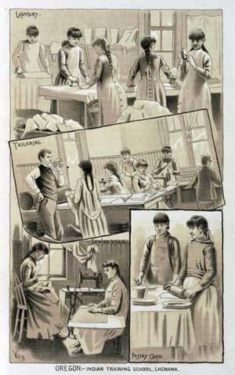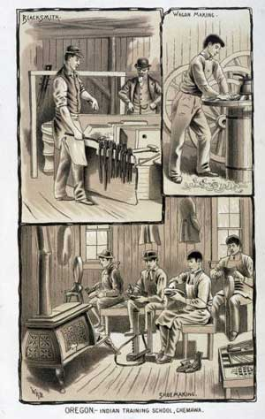
Indian Training School girls activities Indian Training School boys activities

Part 1: Indian Boarding School Movement
The Indian boarding school movement began in the post Civil War era when idealistic reformers turned their attention to the plight of Indian people. Whereas before many Americans regarded the native people with either fear or loathing, the reformers believed that with the proper education and treatment Indians could become just like other citizens. They convinced the leaders of Congress that education could change at least some of the Indian population into patriotic and productive members of society. One of the first efforts to accomplish this goal was the Carlisle Indian School in Pennsylvania, founded by Captain Richard Henry Pratt in 1879. Pratt was a leading proponent of the assimilation through education policy. Believing that Indian ways were inferior to those of whites, he subscribed to the principle, "kill the Indian and save the man." At Carlisle, young Indian boys and girls were subjected to a complete transformation. Photographs taken at the school illustrate how they looked "before" and "after". The dramatic contrast between traditional clothing and hairstyles and Victorian styles of dress helped convince the public that through boarding school education Indians could become completely "civilized". Following the model of Carlisle, additional off reservation boarding schools were established in other parts of the country, including Forest Grove, Oregon (later known as Chemawa). (1)
Seeking to educate increasing numbers of Indian children at lower cost, the federal government established two other types of schools: the reservation boarding school and day schools. Reservation boarding schools had the advantage of being closer to Indian communities and as a result had lower transportation costs. Contact between students and their families was somewhat restricted as students remained at the school for eight to nine months of the year. Relatives could visit briefly at prescribed times. School administrators worked constantly to keep the students at school and eradicate all vestiges of their tribal cultures. Day schools, which were the most economical, usually provided only a minimal education. They worked with the boarding schools by transferring students for more advanced studies.
In the Pacific Northwest, treaties negotiated with the Indians during the 1850s included promises of educational support for the tribes. For example, Article 10 of the Medicine Creek Treaty signed by members of the Nisqually, Squaxin, Puyallup and Steilacoom Tribes on December 26, 1854 called for the establishment of an agricultural and industrial school "to be free to the children of said tribes for a period of 20 years." The expenses of the school, its employees and medical personnel were to be defrayed by the federal government and not deducted from annuities. A similar clause appears in the Treaty of Point Elliott, signed by representatives of tribes living in the central and northern Puget Sound region.
The promised schools did not come into existence for several years. In the 1870s and 1880s a few small reservation boarding schools were established on the Chehalis, Skokomish and Makah Reservations. These institutions, which had fewer than 50 students, were all closed by 1896 and replaced by day schools. In Tacoma, a one-room shack served as a day school for young Puyallup Indians beginning in 1860. By 1873 students had begun boarding at the school and during the 1880s enrollment increased to 125 pupils. At the turn of the century, Cushman Indian School had become a large industrial boarding school, drawing over 350 students from around the Northwest and Alaska. The 1901 Report of Superintendent of Indian Schools praised Cushman for being well equipped for industrial training and photographs show a modern machine shop. Cushman remained one of the largest on reservation boarding schools in the region until it closed in 1920.

Part 2: Mission Schools
Meanwhile, on many reservations missionaries operated schools that combined religious with academic training. At Priest's Point near the Tulalip Reservation, Reverend E.C. Chirouse opened a school in 1857 for six boys and five girls. By 1860 he had 15 pupils and the school continued to grow under the auspices of the Sisters of Providence. At these missionary run schools, traditional religious and cultural practices were strongly discouraged while instruction in the Christian doctrines took place utilizing pictures, statues, hymns, prayers and storytelling.
Some missionary schools received federal support, particularly at times when Congress felt less inclined to provide the large sums of money needed to establish government schools. The Tulalip Mission School became the first contract Indian school, an arrangement whereby the government provided annual funds to maintain the buildings while the Church furnished books, clothing, housing and medical care. In 1896 Congress drastically reduced the funding for mission schools and eventually, in the winter of 1900-01, the Tulalip school became a federal facility. The old school buildings were destroyed by fire in 1902. On January 23, 1905, exactly fifty years after the signing of the Point Elliott Treaty, a new and larger school opened along the shores of Tulalip Bay.
The Tulalip Indian School began under the supervision of Charles Milton Buchanan, a physician who also served as Indian Agent for the reservation. The first year it had only one dormitory, but by 1907 both girls' and boys' buildings were completed and the school had a capacity enrollment of 200 students. The children ranged in age from 6 to 18 years and came from many different reservations as well as some off reservation communities. It was not uncommon for teachers at day schools to recommend certain students for the boarding school. Because Tulalip offered a maximum of eighth grade education, some students transferred to Chemawa for more advanced training.

Part 3: Boarding Schools
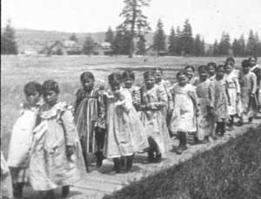
Spokane schoolgirls, Fort Spokane
In eastern Washington, a U.S. military fort near Spokane was transformed into a boarding school for Indians of the Spokane and Colville reservations.
Fort Spokane Boarding School opened in 1900 with an enrollment of 83 pupils and grew to 200 by 1902. It operated only until 1914 after which time the children attended day schools closer to their homes. Similarly, the military facility at Fort Simcoe became a school for the Yakama and their neighbors.
The national system of Indian education, including both off reservation boarding schools, reservation boarding schools and day schools, continued to expand at the turn of the century. In the Pacific Northwest, Chemawa Indian School became the largest off reservation boarding school and drew pupils from throughout the region and Alaska. Chemawa had originally been located at Forest Grove, Oregon, but was moved to Salem in 1885 after officials determined that the original site lacked adequate agricultural land. By 1920 Chemawa enrolled 903 students from 90 different tribes, nearly a third coming from Alaska.
All federal boarding schools, whether on or off reservation, shared certain characteristics. The Bureau of Indian Affairs issued directives that were followed by superintendents throughout the nation. Even the architecture and landscaping appeared similar from one institution to the next. Common features included a military style regimen, a strict adherence to English language only, an emphasis on farming, and a schedule that equally split academic and vocational training. By reading the Reports of the Commissioner of Indian Affairs and other documents you can compare the official reports submitted by various schools.

Part 4: A Typical Daily Schedule
A typical daily schedule at a boarding school began with an early wake-up call followed by a series of tasks punctuated by the ringing of bells. Students were required to march from one activity to the next. Regular inspections and drills took place outdoors with platoons organized according to age and rank. Competitions were held to see which group could achieve the finest marching formation.
Everything happened by bells, 'triangles´ they were called. A triangle would ring in the morning and we would all run, line up, march in, get our little quota of tooth powder, wash our teeth, brush our hair, wash our hands and faces, and then we all lined up and marched outside. Whether it was raining, snowing or blowing, we all went outside and did what was called 'setting up exercises´ for twenty minutes. (Joyce Simmons Cheeka, Tulalip Indian School, memoirs collected by Finley)
Conformity to rules and regulations was strongly encouraged:
We went from the tallest to the littlest, all the way down in companies. We had A, B, C, D companies. E Company was the Lazy Company, those that just couldn't get up and make it. They had all kinds of demerits for those people. They thought they'd shame them a little bit if they made an extra company and called it the Lazy Company. (Helma Ward, Makah, Tulalip Indian School, from interview with Carolyn Marr)
The foremost requirement for assimilation into American society, authorities felt, was mastery of the English language. Commissioner of Indian Affairs T.J. Morgan described English as "the language of the greatest, most powerful and enterprising nationalities beneath the sun." Such chauvinism did not allow for bilingualism in the boarding schools. Students were prohibited from speaking their native languages and those caught "speaking Indian" were severely punished. Later, many former students regretted that they lost the ability to speak their native language fluently because of the years they spent in boarding school.
Another important component of the government policy for "civilizing" the Indians was to teach farming techniques. Although few reservations in the Pacific Northwest had either fertile land or a climate conducive to agriculture, nonetheless it was felt that farming was the proper occupation for American citizens. So boys learned how to milk cows, grow vegetables, repair tools, etc. and even had lessons on the various types of plows. (2)
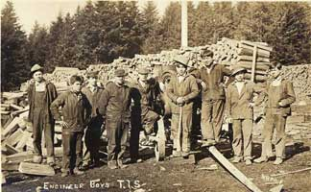
Tulalip Indian School, ca. 1912
The boarding schools had what came to be called the "half and half" system where students spent half of the day in the classroom and half at a work assignment or "detail" on the school grounds. The academic curriculum included courses in U.S. history, geography, language, arithmetic, reading, writing and spelling. Music and drama were offered at most schools. Young women spent either the morning or the afternoon doing laundry, sewing, cooking, cleaning and other household tasks. Older girls might study nursing or office work. The young men acquired skills in carpentry, blacksmithing, animal husbandry, baking and shop. They chopped firewood to keep the steam boilers operating. The work performed by students was essential to the operation of the institution. The meat, vegetables and milk served in the dining room came from livestock and gardens kept by the students. The girls made and repaired uniforms, sheets, and curtains and helped to prepare the meals.
A standardized curriculum for Indian schools emphasized vocational training. Estelle Reel, who served as Superintendent of Indian Education from 1898 to 1910, was a strong advocate of this curriculum which gave primary importance to learning manual skills. No amount of book learning, she felt, could result in economic independence for Indian people. Others would claim that by limiting education to manual training the educators were condemning Indian people to permanent inequality. A former student at the Fort Spokane boarding school described typical work done by the boys:
Some of the boys were detailed to the garden...others were detailed to milk and care for the cows, feed the pigs and chickens and look after the horses, besides doing other chores. There was a large barn on the place, and the boys learned a lot about farming on a small scale. But for boys who had ambitions for becoming something else, Fort Spokane was far from being adequate. (Frances LeBret, as quoted in exhibit They Sacrificed for Our Survival: The Indian Boarding School Experience, at Eastern Washington Historical Museum)
Mandatory education for Indian children became law in 1893 and thereafter agents on the reservations received instructions on how to enforce the federal regulation. If parents refused to send their children to school the authorities could withhold annuities or rations or send them to jail. Some parents were uncomfortable having their children sent far away from home. The educators had quotas to fill, however, and considerable pressure was exerted on Indian families to send their youngsters to boarding schools beginning when the child was six years old. Fear and loneliness caused by this early separation from family is a common experience shared by all former students. Once their children were enrolled in a distant school, parents lost control over decisions that affected them. For example, requests for holiday leave could be denied by the superintendent for almost any reason. (3)

Part 5: Negatives and Positives
For some students, the desire for freedom and the pull of their family combined with strong discontent caused them to run away. At Chemawa, for example, there were 46 "desertions" recorded in 1921, followed by 70 in 1922. Punishment of runaways was usually harsh, as the offenders became examples held up before their fellow students:
Two of our girls ran away...but they got caught. They tied their legs up, tied their hands behind their backs, put them in the middle of the hallway so that if they fell, fell asleep or something, the matron would hear them and she'd get out there and whip them and make them stand up again. (Helma Ward, Makah, interview with Carolyn Marr)
Illness was another serious problem at the boarding schools. Crowded conditions and only the basic medical care no doubt contributed to the spread of diseases such as measles, influenza and tuberculosis. Tuberculosis was especially feared and at the Tulalip Indian School the dormitories were kept cold by leaving the windows open at night. Several students were sent to sanitariums in Idaho or Nevada. In a letter issued to superintendents in 1913, the Indian Office advised disinfecting all textbooks at the end of each school year to reduce the chance of spreading disease. Hospital reports for Tulalip indicate that boys spent a total of 110 days in the hospital during one month and girls 125 days. Death was not an unknown occurrence either. At Chemawa, a cemetery contains headstones of 189 students who died at the school, and these represent only the ones whose bodies were not returned home for burial.
Not all experiences at the boarding schools were negative for all students. In hindsight, former students acknowledge benefits they gained from their education, and there were happy moments for some. Sports, games and friendships are examples of experiences remembered in a positive light.
The boys played baseball, broadjumping and ran foot races, played mumbley peg and marbles, spin the top and a lot of other things for entertainment. (Frances LeBret, Fort Spokane Indian School)
We played baseball, football and a game we call shinney. They get two sticks and tie them together. You got a stick that was curved and you'd hit this and throw it. To score you had to hit a little pole. (Alfred Sam, Snohomish, interview with Carolyn Marr)
As the years went by and most students persevered, strong friendships developed. Occasionally a friendship might end up in marriage, although this certainly was not encouraged by the school. Young people from one culture group met boys and girls from other areas. Reflecting on her years spent in boarding schools, one elder stated:
I think that the sharing in the government boarding school was an important part of that period. Just having the time to share with other Indian students a life that was completely different from your own was something that created a bond. (Vi Hilbert, Upper Skagit, interview with Carolyn Marr)
Another former student recognized the practical advantages offered by the schools but perceived deeper implications:
On the reservations there was no electricity or running water. When kids came to the boarding school they had these things--showers and clean clothes--and they ate decent food. My mom died when I was 13 months old. I stayed with my grandmother who wasn't well...My main criticism of the boarding school is that it didn't allow you to do your own thinking. You marched everywhere, you were governed by the bell and bugle, you were told when to go to bed and when to get up, your whole life was governed. As a result, you didn't learn how to become an independent thinker. (Arnold McKay, Lummi, interviewed by Carolyn Marr)
By the 1920s the Bureau of Indian Affairs had changed its opinion about boarding schools, responding to complaints that the schools were too expensive and that they encouraged dependency more than self-sufficiency. By 1923, the majority of Indian children nationwide attended public schools. A report on Indian education issued in 1928 revealed glaring deficiencies in the boarding schools, including poor diet, overcrowding, below-standard medical service, excessive labor by the students and substandard teaching. The 1930s witnessed many changes in federal Indian policy, among which was a shift in educational philosophy. Classroom lessons could now reflect the diversity of Indian cultures. States assumed more control over Indian education as more children enrolled in public schools. Most of the boarding schools were closed by this time, Tulalip in 1932 and Cushman in 1920, leaving Chemawa as the sole government boarding school remaining in the Pacific Northwest.

Footnotes
1. Harper's Weekly, v.26 (no. 1327), May 27, 1882: 324 (illus.), 327 (text).
2. Curriculum records from National Archives and Records Administration, Pacific Northwest Region, RG75, Box 321: Tulalip Agency.
3.Correspondence from National Archives and Records Administration, Pacific Northwest Region, RG75, Box 321: Tulalip Agency.
------------------------------------------
© University of Washington Libraries
Now, answer the following questions.
- Do you think that the federal government accomplished its goal of assimilating Indians into American society? Why or why not?

- Is it likely that a person's cultural background can be totally erased? Why or why not? What aspects of your own culture do you feel most connected to?

- Why do you think the educators stressed vocational or work-related training over academic or book learning? Was there a built-in prejudice against Indian students evident in this curriculum?

- What do you think self-determination means and how does it differ from the philosophy of the boarding schools?

Sherman Alexie: Interview with Moyers and The Lone Ranger and Tonto Fistfight in Heaven
Sherman Alexie is a poet, fiction writer, and filmmaker known for witty and frank explorations of the lives of contemporary Native Americans. A Spokane/Coeur d’Alene Indian, Alexie was born in 1966 and grew up on the Spokane Indian Reservation in Wellpinit, Washington. He spent two years at Gonzaga University before transferring to Washington State University. In 1991, Alexie published The Business of Fancydancing, a book of poetry that led the New York Times Book Review to call him “one of the major lyric voices of our time.” Since then Alexie has published many more books of poetry, including I would Steal Horses (1993) and One Stick Song (2000); the novels Reservation Blues (1995) and Indian Killer (1996); and the story collections The Lone Ranger and Tonto Fistfight in Heaven (1993), The Toughest Indian in the World (2000), and Ten Little Indians (2003). Alexie also wrote and produced Smoke Signals, a film that won awards at the 1998 Sundance Film Festival, and he wrote and directed The Business of Fancydancing (2002). Living in Seattle with his wife and children, Alexie occasionally performs as a stand-up comic and holds the record for the most consecutive years as World Heavyweight Poetry Bout Champion. His most recent novel is You Don’t Have to Say You Love Me.

To start, click on this link to an interview with Sherman Alexie by Bill Moyers: http://fallsapart.com/video/
Stop at 35 minutes 23 seconds right after Alexie says, “I refuse to participate.” This interview is posted on Sherman Alexie’s website. Feel free to explore his biography and his poetry.

As you watch the video, respond to the following questions. Be sure to clearly explain your ideas.
- Explain the two ways that Alexie describes being lost. How can one feel lost in his/her own culture? As a Native American, he describes himself as an immigrant when he leaves the reservation. Explain.

- Explain the significance of Alexie cutting his hair. Why hasn’t he grown it long again?

- What does Alexie mean when he calls alcohol “medication” for Indians? His father once said, “I drink because I’m Indian.” Explain the significance of that statement.

- Who created reservations? What was the original goal of the reservation system?

- Alexie says, “This country is not good at admitting to its sins.” Explain the context of this quotation.

- Infer a definition of the word “tribe” based on Sherman Alexie’s answers to questions. In what ways do we as Americans still form tribes without realizing or understanding that we are doing so?

- In what ways do Native Americans, specifically Alexie, and Jewish people relate to each other?

- Explain the importance of storytelling in a culture.

The Lone Ranger and Tonto Fistfight in Heaven
Respond, with explanations, to the following questions for excerpts from the novel The Lone Ranger and Tonto Fistfight in Heaven. Cite evidence with page numbers from text when appropriate.
Read This Is What It Means To Say Phoenix, Arizona p. 59-75. Answer the reading questions using quotations and page numbers.

- Why does Victor have to go to Phoenix, Arizona?

- What does Victor need from Thomas Builds-the-Fire and why does he end up taking Thomas with him?

- On the plane, why does Thomas tell Cathy that she has a lot in common with Indians (p. 67)? Explain what he means.

- On page 72, Thomas says that “We are all given one thing by which our lives are measured.” What is that thing for Thomas? What is his gift?

- Why does Victor feel ashamed of himself when he and Thomas return back to the reservation?

- Some of the Native Americans in this and other stories have a combination of traditional Indian names and white names, for instance Thomas Builds-the-Fire. Discuss the meaning of modern Native Americans having the combined names.

- Who was Jim Thorpe? What U.S. state has a city named after him?

Next, read the excerpt entitled “The Trial of Thomas Builds-the-Fire” on pages 93-103. Answer the following questions using quotations and page numbers.
- Research the Bureau of Indian Affairs. What are the main jobs of this government office?

- How could the letter on pages 96-97 be perceived as a metaphor?

- How does this story reinforce the powerlessness of the modern Indian?

- What are some examples of the lies and broken promises whites made to the Indians found in this chapter?

Now, read Family Portrait on pages 191-198. Answer the reading questions using quotations and page numbers.

- According to this chapter, how would you describe HUD housing and what it is like living on the reservation?

- What is the narrator’s message about pain and memory on pages 196-197?

- Why do they dance?

Finally, read “Indian Education” on pages 171-180. Fill in the following chart. In the first column, give a quick summary of the important events that happen at each grade level. In the second column, explain the deeper meaning of the events—what is Alexie really saying?? Hint: look at the last line of each grade to help you figure out the deeper meanings.
Grade | Literal Meaning | Deeper Meaning
First Grade

Second Grade

Third Grade

Fourth Grade

Fifth Grade

Sixth Grade

Seventh Grade

Eighth Grade

Ninth Grade

Tenth Grade

Eleventh Grade

Twelfth Grade

Now, write and explain 2-3 Big Ideas that you see reflected in the Sherman Alexie interview, the excerpts from The Lone Ranger and Tonto Fistfight in Heaven, the poem “Eulogy,” the video “30 Days: Living on the Navajo Indian Reservation,” and “Boarding Schools in the Pacific Northwest.” Please Note: Big Ideas are broad concepts that cover works of literature. For example, a Big Idea for the memoir Night might be discrimination or use of excessive power. Be sure to explain with evidence from text why you have chosen the ideas you have.

Finally, read the poem by Sherman Alexie entitled “Eulogy.” Then, fill out the TPCASTT sheet, giving specific examples that you find in the poem.

Eulogy by Sherman Alexie
My mother was a dictionary.
She was one of the last fluent speakers of our tribal language.
She knew dozens of words that nobody else knew.
When she died, we buried all those words with her.
5 My mother was a dictionary.
She knew words that had been spoken for thousands of years.
She knew words that will never be spoken again.
She knew stories that will never be told again.
My mother was a dictionary.
10 My mother was a thesaurus.
My mother was an encyclopedia.
My mother never taught her children the tribal language.
Oh, she taught us how to count to ten.
Oh she taught us how to say “I love you.”
15 Oh, she taught us how to say “Listen to me.”
And, of course, she taught us how to curse.
My mother was a dictionary.
She was one of the last four speakers of the tribal language.
In a few years, the last surviving speakers, all elderly, will also be gone.
20 There are younger Indians who speak a new version of the tribal language.
But the last old-time speakers will be gone.
My mother was a dictionary.
But she never taught me the tribal language.
And I never demanded to learn.
25 My mother always said to me, “English will be your best weapon.”
She was right, she was right, she was right.
My mother was a dictionary.
When she died, her children mourned her in English.
My mother knew words that had been spoken for thousands of years.
30 Sometimes, late at night, she would sing one of the old songs.
She would lullaby us with ancient songs.
We were lullabied by our ancestors.
My mother was a dictionary.
I own a cassette tape, recorded in 1974.
35 On that cassette, my mother speaks the tribal language.
She’s speaking the tribal language with her mother, Big Mom.
And then they sing an ancient song.
I haven’t listened to that tape in two decades.
I don’t want to risk snapping the tape in some old cassette player.
40 And I don’t want to risk letting anybody else transfer that tape to digital.
My mother and grandmother’s conversation doesn’t belong in the cloud.
That old song is too sacred for the Internet.
So, as that cassette tape deteriorates, I know that it will soon be dead.
Maybe I will bury it near my mother’s grave.
45 Maybe I will bury it at the base of the tombstone she shares with my father.
Of course, I’m lying.
I would never bury it where somebody might find it.
Stay away, archaeologists! Begone, begone!
My mother was a dictionary.
50 She knew words that have been spoken for thousands of years.
She knew words that will never be spoken again.
I wish I could build tombstones for each of those words.
Maybe this poem is a tombstone.
My mother was a dictionary.
55 She spoke the old language.
But she never taught me how to say those ancient words.
She always said to me, “English will be your best weapon.”
She was right, she was right, she was right.
Taken From: “Eulogy.” You Don't Have to Say You Love Me, by Sherman Alexie, Hachette, 2017, pp. 116–120.

TPCASTT
- an analysis method for poetry —

Poem being analyzed: “Eulogy”

Poem’s author: Sherman Alexie

Title
Now, read the poem. Once read, look at the following areas…
Paraphrase (For every 10 lines, put what is happening in your own words.)
Connotation (What literary elements are present in the poem?)
Attitude (What is the author’s attitude towards the subject of the poem? How do you know?)
Shift
(Where in the poem is there a change in the tone or mood? How do you know?)
Title (revisited—now that you have read the poem, what is the significance of the title? How do you know?)
Theme
(What is the message that the poet is trying to have you understand? Why?)

STOP!!!

All items before this page should not be handed in and kept for use on the essay test.

All activities coming after this page should be done on the computer and handed in separately.

Personal Narrative

Personal narratives are often one of the first types of writing that you do. You write about yourself and experiences that you have encountered; therefor, some consider narrative writing the easiest- of course some find it more difficult.

When you write stories from your own experience, you already have a plot.

This particular narrative will focus on one important, or pivotal, event in your life.
Your job will be to make the story interesting - as interesting for your reader as it was for you when it happened.

Lots of sensory description, lots of action, and lots of dialogue will help your reader feel what you felt.
Requirements:
- Autobiographical
  - First person
  - No second person! (you)
  - Ex: I felt a chill when she screamed. . .(YES!) When you do something scary, you sometimes feel. . . (NO!)
Basic Format:
- Introduction with attention getter
- One story with sensory description and dialogue included
- Reflection and conclusion
Attention getter:
  - NO QUESTIONS
  - Lay out the problem, situation, characters…
  - Begin with Dialogue
  - Describe something using sensory detail

Elements that must be present in order to pass:
- Dialogue
- Figurative Language
  - Simile, metaphor, allusions, imagery…
  - Sensory Detail throughout (What did it sound like? Smells? Sights? Tastes?...)
- Reflection
  - What does it all mean? What have you learned? AVOID CLICHES! (I learned that you never know how many days you have left, so live life to the fullest…)
  - Can be the Final paragraph
  - Can be interspersed throughout
Format:
- Length will vary: keeping it to three pages is preferred
- If you are meeting all the requirements, it will probably be at least three pages typed
- The maximum limit is 3 pages double spaced
- MLA format (heading on the left side of page one, 11/12 Font, pages numbered on the right side with last name on each page…)
- DOUBLE SPACED
- Try to print on one side of the page only
- Did we mention…? NO SPELLING OR GRAMMATICAL ERRORS!

Consider organization:
- Chronological
- Events should build
- No “and then…”
- Use transition words and phrases

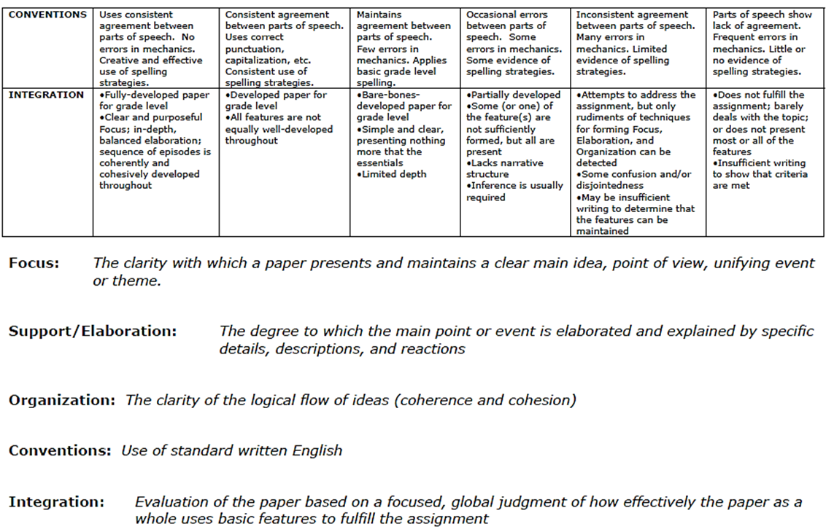
Writing Process Checklist for your use
Drafting
_____ thought about purpose for writing
_____ format is followed correctly according to directions
___introduction with attention getter (NO questions)
___sensory description
___dialogue
___reflection
_____one pivotal event is present
_____ rough draft written

Revising
_____ went through individually and made changes based on inclusion of pertinent ideas
_____ gave clear thought to, and made changes in, word choice
_____ draft was read aloud to partner
_____ draft taken to ERC (book room) for editing and feedback
_____ at least three comments are made by peer/parent editor
_____ changes have been made to reflect suggestions of editor

Editing
_____ made necessary changes in areas of grammar, spelling, mechanics and format.
_____ there is a title and heading on the upper left- hand corner

Publishing
_____ Final copy was handed in on time with edited rough draft(s) and Rubric attached to the back

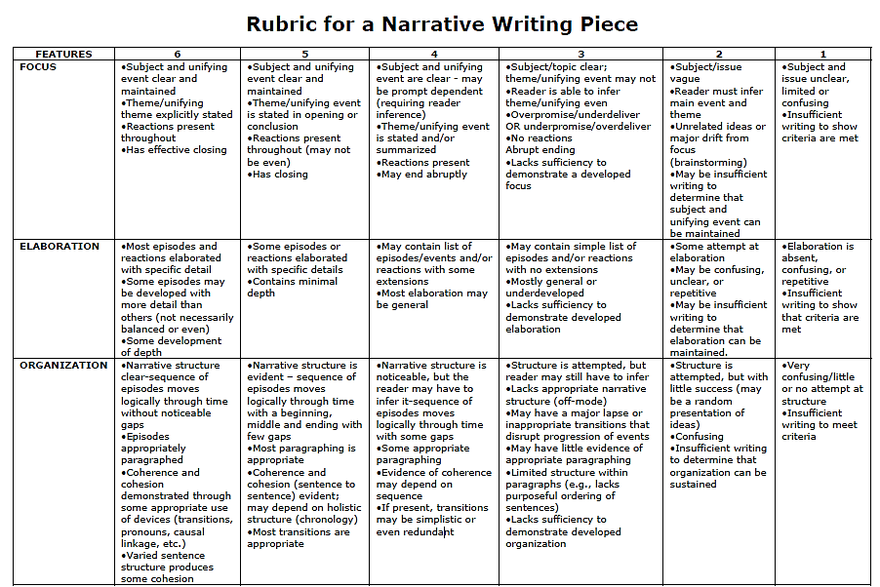
Use of dialogue
Effective attention getter
Sensory / Descriptive language
REFLECTION | Thoughtful coherent reflection  Appropriate depth  Provides an overall analysis of the event(s) in the narrative | Some reflection  Minimal depth  Some analysis but needs more elaboration | Contains some general reaction to event(s) but lacks depth  Elaboration is general | General /simplistic reactions to event(s)  No elaboration | Attempt at reflection made  May be unclear, unconnected or confusing  Insufficient elaboration | No attempt at reflection made  Does not meet requirement

Clear evidence of an edited rough draft, stapled to the back of the final draft: 0 1 2 3 4
Total Score: _____ / 40
Attach this rubric to the back of your final draft and edited rough draft before handing it in.

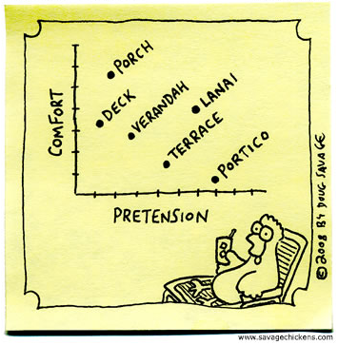
Vocabulary Development

Directions:
Using the website below, complete each of the five online tests indicated below. After completing each test and obtaining a score you feel proud of, print out the results sheet (see page 32 for specific instructions/visuals).

Keep track of your printouts and be prepared to turn them in the first week of school.

You are welcome to do any of the other available tests at this level as extra practice, but by no means are they required.

http://www.vocabtest.com/high_school/sophomore.php

Unit | Required Online Tests  print out results sheets once completed (see next page for details) | Remember  You can take each test as often as you need to in order to obtain your desired score (ideally, 100%); however, only one printout of each is to be turned in, so turn in your best results for each test.
1 | - Learning Definitions  - Synonym Practice  - Reverse Sentences
2 | - Reverse Definitions  - Antonyms Online  - Vocabulary Sentences
3 | - Learning Definitions  - Reverse Synonym  - Reverse Sentences
4 | - Reverse Definitions  - Reverse Antonyms  - Vocabulary Sentences
5 | - Learning Definitions  - Synonym Practice  - Reverse Sentences
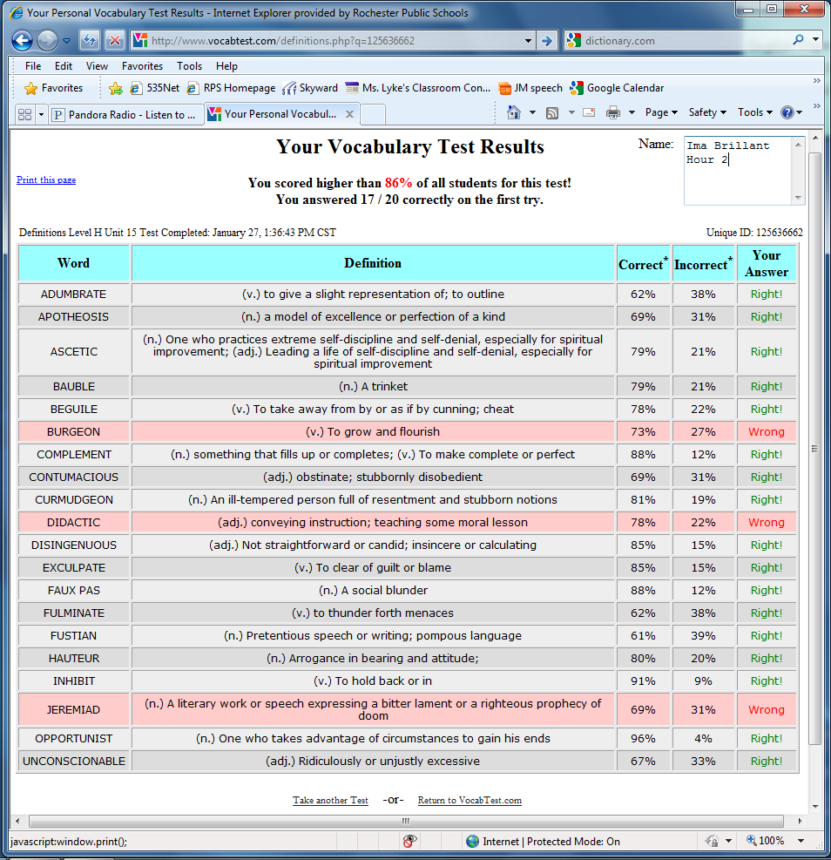
Once you finish an online test, you will have a screen similar to this pop up. Fill in your name (and hour, if you know it) in the upper right corner and then click on “print this page” in the upper left corner.

These printed results pages are what you are to turn in on the first day of school;
there should be 15 in total when you are all done.

