Name Date Hour

Study Guide for The Great Gatsby

Directions: Gather with your small group and, through the sharing out of information, fill in the boxes below.

 | The basic facts | Impact on Literature
F. Scott Fitzgerald
The Roaring 20’s
Modernism
Directions: Fill in the following boxes as you read the novel. You do not need to use complete sentences, but you do need to be as detailed as possible: this means adding to the chart at various parts of the book.

 | Does this character have an alias?  If so, what is it? | Character’s relationship to other characters. | Character Information  Appearance, Personality, Occupation, Significant Events, etc.
Jay Gatsby
Nick Carraway
Daisy
Buchannan
Tom Buchannan
Jordan Baker
Myrtle Wilson
George Wilson
Catherine
Meyer Wolfshiem
Michaelis
Ewing Klip-springer
Dan Cody
Henry C. Gatz
Directions: Answer each of the following questions thoroughly and specifically. Whenever possible, use a quote or two as support (remember to cite using MLA requirements).
Chapter 1
- Nick starts the novel by relaying his father’s advice that, “Whenever you feel like criticizing anyone, just remember that all people in this world haven’t had the advantages that you’ve had.” List Nick’s advantages according to what has been provided in chapter 1.
- Describe Nick. What factors do readers know about him, and what can readers infer about him? What kind of a narrator might he turn out to be?
- How does the author describe Jordan Baker? What does her behavior reveal about her?
- How does Nick react to Jordan?
- What does Tom’s behavior reveal about his character?
- What comment does Daisy make about her daughter and what does Daisy’s comment reveal about her own character?
- What glimpse of Gatsby does Nick have? What does Gatsby seem to be focusing his attention on?
Chapter 2
- Describe the “valley of ashes.” What does it look like and what does it represent?
- Contrast Mr. Wilson and Myrtle. Do they seem to fit into their setting?
- Compare and contrast the party in East Egg with the party in New York.
- At the party in New York, what makes Nick an unreliable narrator? What literary technique is used here that helps establish this unreliability?
- As per his father’s advice, does Nick reserve judgment so far in the novel?
Directions: After reading chapter 2, fill in the following boxes for the vocabulary pertaining to chapters 1-2.

 | POS + a definition in 1-8 words | Picture that visually  represents the word | A sentence that uses  the word correctly
Feigned | (verb)  to Pretend | 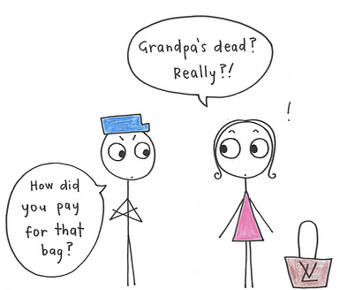  What Bag? This old thing? | She feigned surprise when the police officer asked her about the stolen bag, which caused the officer to be confused.
Bantering
Complacency
Infinite
Desolate | (adjective)  deserted, bleak, empty,  depressing | 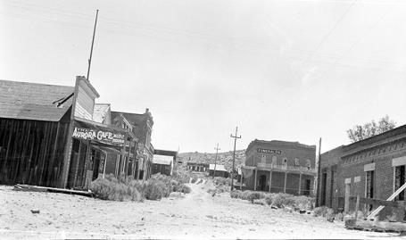 | The town looked dirty and desolate; there was no one in sight.
Supercilious
Apathetic
Languid

Directions: Answer each of the following questions thoroughly and specifically. Whenever possible, use a quote or two as support (remember to cite using MLA requirements).

Chapter 3
- What observation does Nick make about Gatsby’s guests?
- What rumors are told about Gatsby? Why might the author reveal rumors rather than fact?
- What does Nick think of Gatsby after meeting him?
- How does Gatsby stand in sharp contrast with his guests?
- Interpret the purpose or role that Owl Eyes plays at the party.
- What does Nick do that suggests that he maintains his integrity and Midwestern values?
- By the end of this chapter, readers have observed three parties, what do these parties and their setting reveal about their participants?
- How does Nick’s self-professed honesty align with/juxtapose his attraction to Jordan Baker?
Chapter 4
- Why do you suppose Fitzgerald lists all of Gatsby’s party guests?
- What does Gatsby tell Nick about his life? Do you believe Gatsby? Does Nick?
- What role does Meyer Wolfsheim play in the novel? How does his behavior and lack of social grace reflect upon Gatsby?
- As reported by Jordan, how does Daisy and Gatsby’s relationship resemble a fairytale?
- What new realization does Nick have about Gatsby and his ostentatious display of wealth?
- What symbolic value does the green light now have?
- In what way does the plot of The Great Gatsby not really begin until chapter 4?
Directions: After reading chapter 4, fill in the following boxes for the vocabulary pertaining to chapters 3-4.

 | POS + a definition in 1-8 words | Picture that visually  represents the word | A sentence that uses  the word correctly
Vehemently
Credulity
Cynical | (adjective)  Distrusting, specifically distrusting in the motivation of others
Affectation
Labyrinth |  | 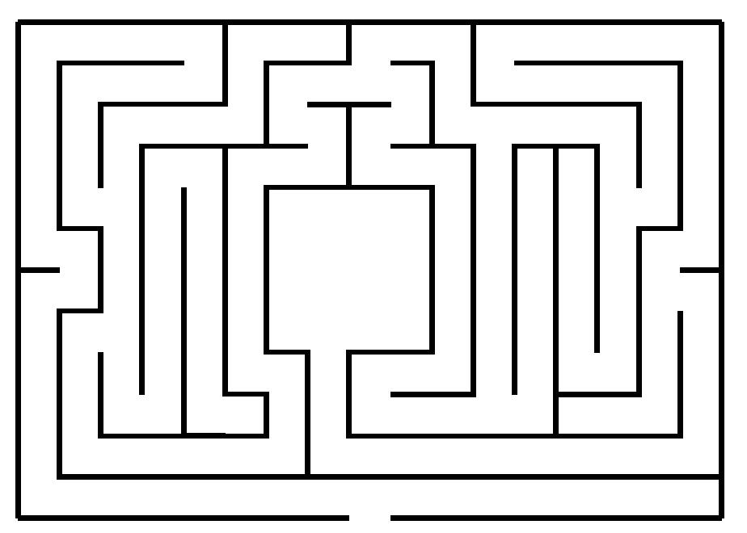
Disconcerting
Juxtaposition
Fluctuate |  |  | In Minnesota the temperatures in spring tend to fluctuate; for this reason, I often dress in layers from March to June.

Directions: Answer each of the following questions thoroughly and specifically. Whenever possible, use a quote or two as support (remember to cite using MLA requirements).

Chapter 5
- What do the goods and services delivered to Nick’s house suggest about Gatsby?
- Why does Gatsby offer Nick “a little business on the side”? How does Nick respond?
- Describe the effect of rain on the plot. When does it stop?
- What significance is there in Gatsby knocking over Nick’s clock?
- Describe Daisy’s reaction to Gatsby’s possessions. Why do the shirts make her cry?
- What does the frequency and mysteriousness of Gatsby’s phone calls suggest?
- What does Nick speculate about Daisy meeting Gatsby’s expectations?
Chapter 6
- How truthful was Gatsby when he first relayed the story of his life to Nick? Why does
Fitzgerald tell the story of Jay Gatz now?
- What impact did Dan Cody have on Jay Gatz?
- Describe the meeting of Tom and Gatsby. What does this meeting reveal about them?
- Why did Daisy and Tom find Gatsby’s party loathsome?
- How did Gatsby measure the success of his party?
- When Nick told Gatsby that “you can’t repeat the past,” Gatsby replied, “Why of course you can!” Do you agree with Nick or with Gatsby?
Directions: After reading chapter 6, fill in the following boxes for the vocabulary pertaining to chapters 5-6.

 | POS + a definition in 1-8 words | Picture that visually  represents the word | A sentence that uses  the word correctly
Simultaneous
Defunct |  |  | After my brother sat on my watch, it was completely defunct; therefore, I asked for a new one for my birthday.
Distraught
Hulking
Turbulent |  | 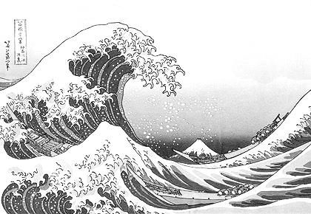
Profusion
Oblivion | (noun)  unaware/ unconscious of what’s happening
A word of your choosing from chapter 5/6:

_____________

Directions: Answer each of the following questions thoroughly and specifically. Whenever possible, use a quote or two as support (remember to cite using MLA requirements).

Chapter 7
- How does Daisy and Gatsby’s new relationship influence his lifestyle?
- What does the oppressively hot weather foreshadow in relation to the meeting of Tom and Gatsby?
- Explain Gatsby’s reaction to Daisy’s daughter? What implication does she have for his dream?
- Compare and contrast George Wilson and Tom Buchanan. What did each man learn about his wife and how did they each react?
- Why does Fitzgerald have the confrontation occur in New York City?
- What does Gatsby want Daisy to tell Tom? Why? What is her response?
- Why is Nick’s 30th birthday a significant turning point for him? In what way is his summer in the east a parallel to Gatsby’s year with Cody?
- What was the final outcome of the confrontation at the Plaza? How does it mark the end of Gatsby’s dream?
- Describe the circumstance of Myrtle’s death. How is it symbolic?

Chapter 8
- Again, how does Fitzgerald use weather and the seasons to highlight change in the novel?
- How does Nick’s statement, “You’re worth the whole bunch put together” show a change in Nick from the beginning of the novel? Do you agree with him? Why?
- How is Gatsby set apart from the Bakers and the Buchanans of the world?
- How does Mr. Wilson view T. J. Eckleberg?
- How is Gatsby’s death symbolic?
Chapter 9
- Why did Nick arrange Gatsby’s funeral? Also, who attended Gatsby’s funeral? How and why is this significant?
- How was Jay Gatz’s childhood schedule consistent with the adult Gatsby’s behavior?
- On a symbolic level, what is the purpose of Nick’s last meeting with Jordan?
- Why does Nick call Tom and Daisy “careless people”?
- What does the novel’s outcome imply about the American Dream of the 1920’s and today? (This may require you to do a bit of research on what ‘The American Dream’ is?
Directions: After reading chapter 9, fill in the following boxes for the vocabulary pertaining to chapters 3-4.

 | POS + a definition in 1-8 words | Picture that visually  represents the word | A sentence that uses  the word correctly
Intermittent
Presumptuous
Formidable
Incessant
Pervaded
Corroborate
Garrulous
Superfluous
Deferred
Transitory
A word of your choosing from chapter 7/8/9:

_____________

