From Trayvon Martin to ‘black lives matter’
by Jonathan Capehart — Feb. 27, 2015

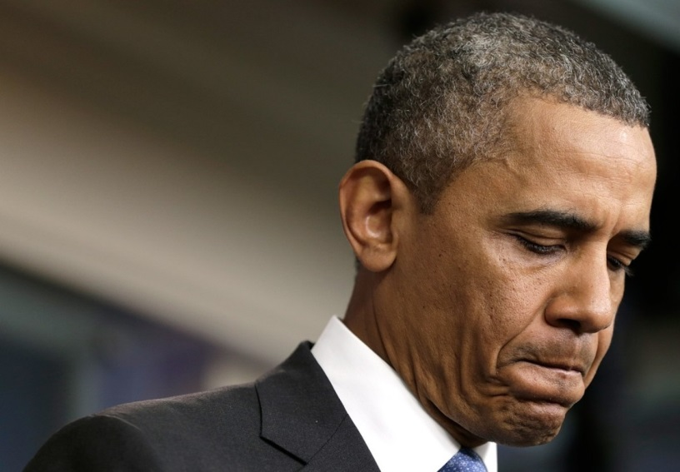
On July 19, 2013, President Obama discussed the acquittal of George Zimmerman in the 2012 killing of Trayvon Martin. (Win McNamee/Getty Images)
If the grand jury decisions to not indict the police officers involved in the deaths of Michael Brown and Eric Garner gave birth to the “black lives matter” movement, then it was conceived in the early evening of Feb. 26, 2012, in Sanford, Fla. That was the night George Zimmerman shot and killed unarmed 17-year-old Trayvon Martin. That night began the nation’s awakening to the heavy weight of other people’s suspicions borne by African Americans, men and boys in particular. That was the night that led to the president of the United States, the first African American elected to the position, to say a month later in the Rose Garden, “If I had a son, he’d look like Trayvon.”
Days after a jury found Trayvon’s killer not guilty in July 2013, Obama made a surprise appearance in the White House press briefing room to deliver the most powerful remarks on race since his speech on the subject that saved his presidential campaign in 2008.

And when you think about why, in the African American community at least, there’s a lot of pain around what happened here, I think it’s important to recognize that the African American community is looking at this issue through a set of experiences and a history that doesn’t go away.

There are very few African American men in this country who haven’t had the experience of being followed when they were shopping in a department store. That includes me. There are very few African American men who haven’t had the experience of walking across the street and hearing the locks click on the doors of cars. That happens to me — at least before I was a senator. There are very few African Americans who haven’t had the experience of getting on an elevator and a woman clutching her purse nervously and holding her breath until she had a chance to get off. That happens often.

And I don’t want to exaggerate this, but those sets of experiences inform how the African American community interprets what happened one night in Florida. And it’s inescapable for people to bring those experiences to bear. The African American community is also knowledgeable that there is a history of racial disparities in the application of our criminal laws — everything from the death penalty to enforcement of our drug laws. And that ends up having an impact in terms of how people interpret the case.

Since that rainy night three years ago, we have watched one horrific encounter after another involving unarmed African Americans on the losing end of a gun or a confrontation with police. Jordan Davis, 17, shot and killed in Jacksonville, Fla., on Nov. 23, 2012 by Michael Dunn. Renisha McBride, 19, shot and killed in Dearborn Heights, Mich., on Nov. 2, 2013 by Theodore P. Wafer. Eric Garner, 43, killed in chokehold on Staten Island in New York City on July 17, 2014, by police officer Daniel Pantaleo. John Crawford, 22, shot and killed by police in Beavercreek, Ohio, on Aug. 5, 2014. Michael Brown shot and killed in Ferguson, Mo., on Aug. 9, 2014, by then-police officer Darren Wilson. Tamir Rice, 12, in Cleveland on Nov. 23, 2014, by police officer Timothy A. Loehmann. The killers of Davis and McBride were found guilty and are in jail. The police officers involved in the killings of Crawford, Garner and Brown were not indicted. The officer who killed Tamir is on restricted duty.
And what happened to Levar Jones, 35, is every African American’s worst nightmare. On Sept. 4, 2014, he was pulled over by South Carolina state trooper Sean Groubert for a seat-belt violation. A request to see his driver’s license followed by an attempt to comply led to unarmed Jones being shot by Groubert. Jones survived. Groubert was fired and faces up to 20 years if convicted of assault and battery.
Demonstrators walk together during a protest Dec. 3, 2014, in New York. Protests began after a grand jury decided to not indict officer Daniel Pantaleo for the death of Eric Garner. (Yana Paskova/Getty Images)
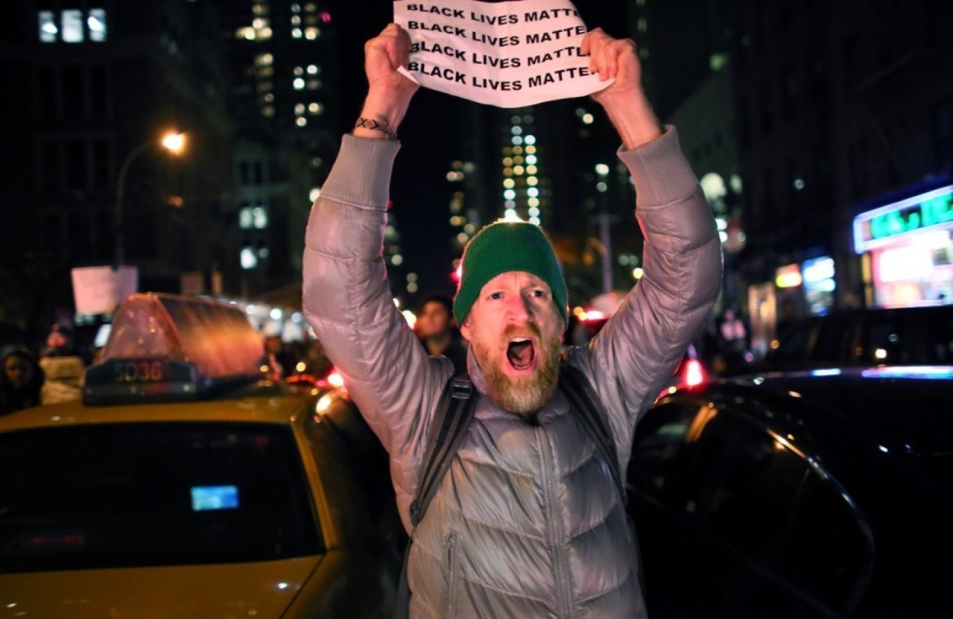
Sprinkled throughout that numbing timeline were actions that advanced our tortured national conversation on race. The Justice Department opened civil rights investigations into the deaths of Trayvon and of Brown. Earlier this week, DOJ announced no charges would be filed against Zimmerman. Federal charges against Wilson are not expected. But there are reports that DOJ will file a pattern-and-practice suit against the Ferguson police department. Last December, a DOJ investigation of the Cleveland police force that preceded the killing of Tamir found a pattern of excessive force. The key is that the nation’s chief law enforcement agency was and is taking these cases seriously and putting jurisdictions around the country on notice that they will be held accountable.
Two years after the killing of Trayvon, the president focused a spotlight on the plight young men and boys of color with his “My Brother’s Keeper” initiative. The reprehensible reaction by law enforcement to the protests in Ferguson last summer led to a broader awareness of the racial makeup of police departments, the militarization of local police and the criminalization of the poor. And the multiracial “Black Lives Matter” demonstrations that erupted across the country last November and December in the wake of those grand jury decisions in Missouri and New York City were a sign of progress. Black lives finally mattered to everyone.

But the December murder of New York City police officers Wenjian Liu and Rafael Ramos while sitting in their patrol car in Brooklyn added a new dimension to the conversation. For the first time, we heard respected leaders from law enforcement acknowledge the long-held pain of African Americans and their mistrust of the police as a way to build a bridge to greater understanding.
When “Meet The Press” moderator Chuck Todd asked New York City Police Commissioner William Bratton in December if he acknowledged the rift between blacks and the police, Bratton was clear. “Oh, certainly,” he said. “I interact quite frequently with African Americans from all classes, from the rich to the poor. And there’s not a single one that has not expressed this concern, that their perception is the reality that we have to deal with.”
FBI Director James Comey devoted an entire speech to law enforcement and race at Georgetown University this month that focused on four “hard truths” for police. He discussed how “our history is not pretty” in dealing with “disfavored groups.” He talked about how unconscious bias is as much a problem for police as it is for society as a whole. And he talked about the cynicism that cops “work hard to resist” while facing young men and boys of color grappling with staggering problems.
During a December interview with BET, the president was asked to react to criticism that he hasn’t been “aggressive enough” in talking about all the cases of black men shot by whites. Obama pushed back.
Well, sometimes people’s concerns are not based on fact, because if you look at after what happened with Michael Brown, if you looked at what happened after Trayvon, if you looked at the decision after Eric Garner, I’m being pretty explicit about my concern, and being pretty explicit about the fact that this is a systemic problem, that black folks and Latinos and others are not just making this up.
A tragically positive legacy of the killing of Trayvon Martin is that it began to open the nation’s eyes. That people of color are not “just making things up” when it comes to the sometimes fatal racism, discrimination and suspicions they face. As a result, the chant of “black lives matter” is not the lament of a disaffected minority but the mantra of a nation awakened to and tired of the injustice and brutality faced by their fellow Americans.

Capehard, Jonathan. "From Trayvon Martin to ‘black Lives Matter’." The Washington Post, 27 Feb. 2015. Web. 18 May 2015.

